Employee Salary Prediction System

Project Id: 3

Name : Darsh Bhardwaj
Class Roll Number:39
University Roll Number : 2028696
Section and Group: G(G1)

Name : Akshat Joshi
Class Roll Number:30
University Roll Number : 2028632
Section and Group: G(G1)

Name : Aarav
Class Roll Number:25
University Roll Number : 2028603
Section and Group: G(G1)

- Problem Description 3
- Architecture 4
- Models model 5
- Evaluation metrics used 6
- Preliminary Results and Visualizations 7
- References 8

- Problem Description
In any company, deciding how much salary to give an employee is a very important and sensitive decision. It depends on many factors like experience, education, job role, performance skills, and even how satisfied the employee is with the job. If this decision is based only on guess work or personal judgement , it can become unfair and may also waste time for the HR team .
In this project, we are building a simple machine learning system that can predict the salary of an employee using regression. Instead of using real company data, we will create our own synthetic dataset with 20 features such as age, years of experience, education level, job level department, job role and performance rating. Using this data, we will apply Linear Regression, Ridge Regression and Lasso Regression to predict salary and compare their performance using the R² score and RMSE. This will help us understand how data‑driven models can support fair and consistent salary decisions in an organization.

- Architecture
- Data Loading: The cleaned_employee_dataset.csv is imported.
- Sequential Feature Selection: We use a SequentialFeatureSelector to identify the top 8 most influential features (e.g., Age, Experience, JobRole, PerformanceRating) to reduce noise and improve model speed.
- Data Splitting: Data is divided into 80% for training and 20% for testing.
- Model Training:
• KNN Regressor: Trained with k=5 neighbors.
• Decision Tree Regressor: Trained with a max_depth=5 to prevent overfitting.
- Model Evaluation: Performance is measured using R² and RMSE scores.
- Persistence: The final models are saved as .pkl files for use in the interactive prediction script.

- Models Used(Applied/ Planned) Give a brief introduction of the models used

• K-Nearest Neighbors (KNN): A non-parametric method that predicts the salary of an employee by looking at the "k" most similar employees in the dataset. It is effective at capturing localized patterns.
• Decision Tree Regression: A model that breaks down the dataset into smaller subsets while at the same time an associated decision tree is incrementally developed. It handles non-linear relationships and feature interactions exceptionally well.

- Evaluation metrics used

• R² Score (Coefficient of Determination): Measures how well the models explain the variance in salary. (Goal: Closer to 1.0)
• RMSE (Root Mean Squared Error): Measures the average error (in ₹) between the predicted and actual salary. (Goal: Lower value)

- Preliminary Results and Visualizations

Based on the execution of phase2_models.ipynb, the models achieved the following results:

Model | R2 Score | RMSE (Average Error)
KNN Regression | 0.9087 | ₹ 1,51,151.41
Decision Tree Regression | 0.9358 | ₹ 1,26,783.58

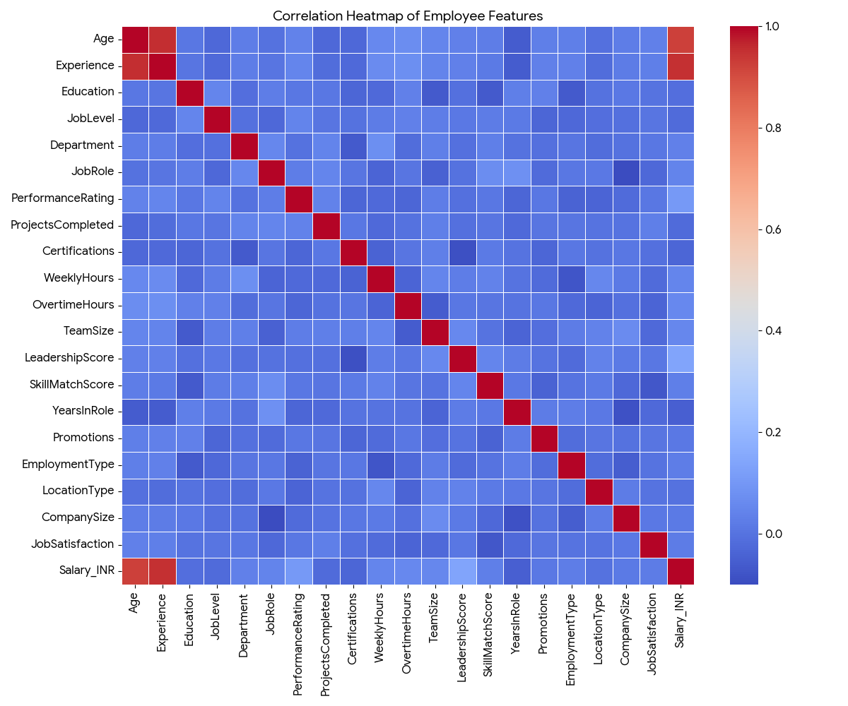

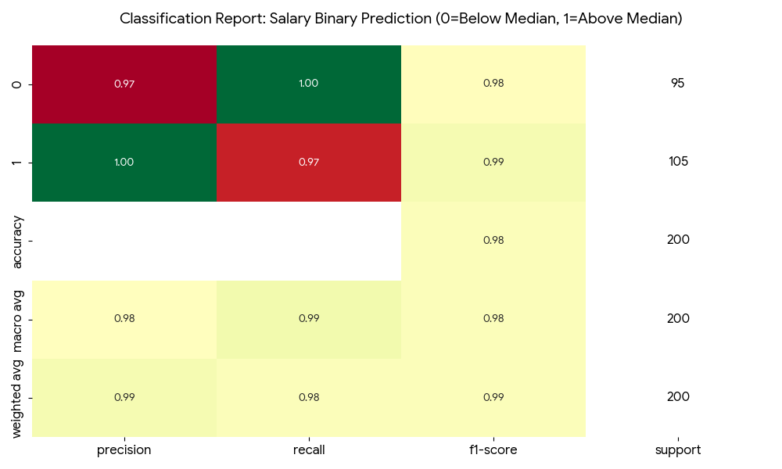

6. References:
Books:
- Let Us Python – Yashavant Kanetkar

Online Resources:
  - GeeksforGeeks – https://www.geeksforgeeks.org/
  - TutorialsPoint – https://www.tutorialspoint.com/cprogramming/index.htm
  - Stack Overflow – https://stackoverflow.com

